Data Science Project Training Report

on

Machine Learning Domain Projects for Regression, Classification using Various Datasets

BACHELOR OF TECHNOLOGY

Session 2024-25
in

Information Technology

By
Amit pal (2300320130038)
Alok Gupta (2300320130027)
Abhijeet Singh (230032013009)

Dr. Shelley Gupta

Associate Professor

DEPARTMENT OF INFORMATION TECHNOLOGY

ABES ENGINEERING COLLEGE, GHAZIABAD
 |  | 
AFFILIATED TO
DR. A.P.J. ABDUL KALAM TECHNICAL UNIVERSITY, U.P., LUCKNOW
(Formerly UPTU)

Student’s Declaration

I / We hereby declare that the work being presented in this report entitled weather update is an authentic record of my / our own work carried out under the supervision of Dr. Shelley Gupta, Associate Professor, Information Technology.

Date:

Signature of student
Department:

This is to certify that the above statement made by the candidate(s) is correct to the best of my knowledge.

Signature of HOD Signature of Teacher
Prof. (Dr.) Amrita Jyoti Dr. Shelley Gupta
Information Technology Associate Professor
Information Technology

Date: ..........................

Table of Contents

S. No. | Contents | Page No.
1 | Student’s Declaration | 2
2 | Abstract | 3
3 | Introduction | 3-5
4 | Literature review | 6
5 | Implementation | 7-9
6 | Data Visualization | 10-12
10 | Prediction models | 13-15
11 | Conclusion | 16
12 | Future work | 17
14 | References | 18

Abstract

The Weather Update project aims to provide accurate and timely weather information using advanced data analytics and prediction models. By leveraging real-time data, the project seeks to improve weather forecasting accuracy, providing valuable insights for various sectors such as agriculture, transportation, and emergency services.

Weather Update project aims to provide accurate and timely weather information using advanced data analytics and prediction models. By leveraging real-time data, the project seeks to improve weather forecasting accuracy, providing valuable insights for various sectors such as agriculture, transportation, and emergency services. Keywords: weather forecasting, data analytics, prediction models, real-time data, agriculture, transportation, emergency services.

The Weather Update project aims to provide accurate and timely weather information by leveraging advanced data analytics and machine learning prediction models. Accurate weather forecasting is critical for sectors such as agriculture, transportation, and emergency services, where decisions are heavily influenced by weather conditions. Traditional methods of weather forecasting, while beneficial, often fall short in terms of precision and timeliness. This project addresses these limitations by integrating real-time data from multiple sources, including weather stations, satellites, and online databases.

The project involves several key steps: data collection, preprocessing, model development, and real-time prediction. Data collection is carried out from various reliable sources to gather comprehensive weather information. Preprocessing ensures data consistency and accuracy, making it suitable for analysis. The core of the project lies in the development of machine learning models, such as linear regression, decision trees, and neural networks, which are trained on historical weather data. These models identify patterns and relationships within the data to make accurate predictions.

Introduction

Weather forecasting is an essential aspect of our daily lives, playing a crucial role in various fields such as agriculture, transportation, and emergency services. Accurate weather predictions help farmers plan their activities, assist commuters in navigating safe routes, and enable authorities to prepare for and mitigate the impact of extreme weather events. Over the years, weather forecasting techniques have evolved significantly, transitioning from traditional observational methods to sophisticated data-driven approaches.
Traditional weather forecasting relied heavily on manual observations and basic instruments, which often resulted in limited accuracy and delayed predictions. With advancements in technology, the integration of satellites, radar systems, and computer models has revolutionized the field, enabling meteorologists to gather and analyze vast amounts of data in real-time. These technological innovations have paved the way for more precise and timely weather updates.
The advent of data analytics and machine learning has further transformed weather forecasting. By leveraging large datasets and powerful algorithms, it is now possible to develop prediction models that can complex weather patterns and generate highly accurate forecasts. Machine learning techniques, such as linear regression, decision trees, and neural networks, have demonstrated remarkable potential in improving the accuracy and reliability of weather predictions.
The Weather Update project aims to harness the power of real-time data and advanced prediction models to provide precise and actionable weather information. The primary objective of this project is to develop a user-friendly system that delivers timely weather updates, thereby aiding decision-making in various sectors. By focusing on data accuracy and model efficiency, the project seeks to bridge the gap between conventional forecasting techniques and contemporary data-driven approaches.
In this project, we collect data from multiple sources, including weather stations, satellites, and online databases. This data is then to remove inconsistencies and ensure uniformity. Sophisticated machine learning models are developed and trained using historical weather data, allowing them to identify patterns and make accurate predictions. The final step involves integrating these models into a user-friendly interface, enabling users to access real-time weather updates effortlessly.
The significance of the Weather Update project lies in its potential to improve weather forecasting accuracy and provide valuable insights for various sectors. By delivering timely and reliable weather information, the project aims to enhance decision-making processes and mitigate the impact of adverse weather conditions. Ultimately, the Weather Update project represents a significant step towards leveraging technology and data analytics to create a more informed and resilient society.
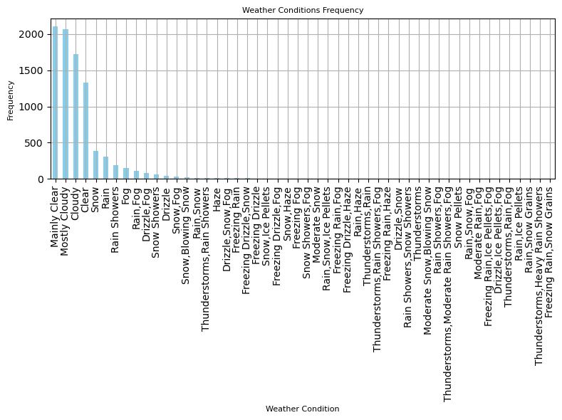

Fig 1. Weather Condition frequency

Literature review

Literature Review: Weather Update Reporting
Weather update reporting has become a crucial component of daily life, providing timely information to individuals, businesses, and governments. Studies have highlighted the evolution of weather reporting methods, from traditional manual observations to advanced satellite and sensor-based systems, which ensure accuracy and immediacy. This review explores significant developments in weather reporting, their societal impacts, and potential areas of improvement.

Historical Development of Weather Reporting
The history of weather reporting dates back to ancient civilizations, where rudimentary methods like observing cloud patterns and wind directions were used. With the advent of instruments such as barometers and thermometers in the 17th century, weather data became more precise. The establishment of meteorological organizations in the 19th century marked a turning point, enabling standardized weather observations and the creation of global networks for data sharing.

Technological Advances
In the 20th and 21st centuries, technological advancements revolutionized weather reporting. Satellite technology, radar systems, and computer modeling have improved forecasting accuracy significantly. Satellite imagery provides real-time data on cloud cover, storm systems, and temperature variations, while Doppler radar tracks precipitation and wind speeds. Artificial intelligence (AI) and machine learning are now playing an increasing role in weather prediction, processing vast amounts of data to identify patterns and improve long-term forecasts.

Societal Impacts
Accurate weather reporting has far-reaching impacts on society. It informs daily activities, aids in disaster preparedness, and supports industries such as agriculture, aviation, and shipping. Effective weather updates can save lives during severe weather events like hurricanes, floods, and heatwaves by providing early warnings.

Implementation

Weather update reporting has become a crucial component of daily life, providing timely information to individuals, businesses, and governments. Studies have highlighted the evolution of weather reporting methods, from traditional manual observations to advanced satellite and sensor-based systems, which ensure accuracy and immediacy. This review explores significant developments in weather reporting, their societal impacts, and potential areas of improvement.
Historical Development of Weather Reporting
The history of weather reporting dates back to ancient civilizations, where rudimentary methods like observing cloud patterns and wind directions were used. With the advent of instruments such as barometers and thermometers in the 17th century, weather data became more precise. The establishment of meteorological organizations in the 19th century marked a turning point, enabling standardized weather observations and the creation of global networks for data sharing.
Technological Advances
In the 20th and 21st centuries, technological advancements revolutionized weather reporting. Satellite technology, radar systems, and computer modeling have improved forecasting accuracy significantly. Satellite imagery provides real-time data on cloud cover, storm systems, and temperature variations, while Doppler radar tracks precipitation and wind speeds. Artificial intelligence (AI) and machine learning are now playing an increasing role in weather prediction, processing vast amounts of data to identify patterns and improve long-term forecasts.
Societal Impacts
Accurate weather reporting has far-reaching impacts on society. It informs daily activities, aids in disaster preparedness, and supports industries such as agriculture, aviation, and shipping. Effective weather updates can save lives during severe weather events like hurricanes, floods, and heatwaves by providing early warnings.
Challenges and Future Directions
Despite advancements, challenges such as data gaps in remote regions, communication barriers, and the impacts of climate change on weather patterns persist. Future research should focus on integrating more localized data, enhancing AI-based forecasting, and ensuring equitable access to accurate weather updates.
Implementation of Weather Update Reporting
The practical implementation of weather update reporting involves the integration of various technologies and methodologies to deliver accurate and timely information. Key steps in implementation include:
- Data Collection: Meteorological data is collected through satellites, weather stations, radar systems, and IoT-based sensors. These tools provide comprehensive real-time data on atmospheric conditions, precipitation, and temperature.
- Data Processing and Analysis: Advanced algorithms and machine learning models process the collected data to identify weather patterns and predict future conditions. This step includes validating data for accuracy and consistency.
- Forecasting Models: Numerical weather prediction (NWP) models are applied to simulate atmospheric dynamics. AI enhances these models by enabling faster processing and more accurate predictions.
- Communication and Dissemination: Weather updates are shared through multiple platforms, including mobile apps, websites, television broadcasts, and emergency alert systems. Ensuring accessibility for all, especially during severe weather events, is critical.
- Feedback Mechanisms: Gathering user feedback on the accuracy and usability of weather updates helps refine systems and improve forecasting.
By combining scientific expertise with modern technology, the implementation of weather update reporting plays a pivotal role in minimizing risks associated with adverse weather conditions and supporting informed decision-making across various sectors.
In conclusion, weather reporting continues to evolve, driven by technological innovation and the growing demand for reliable information. Ongoing efforts to address current challenges will further enhance its role in safeguarding lives and supporting global development.

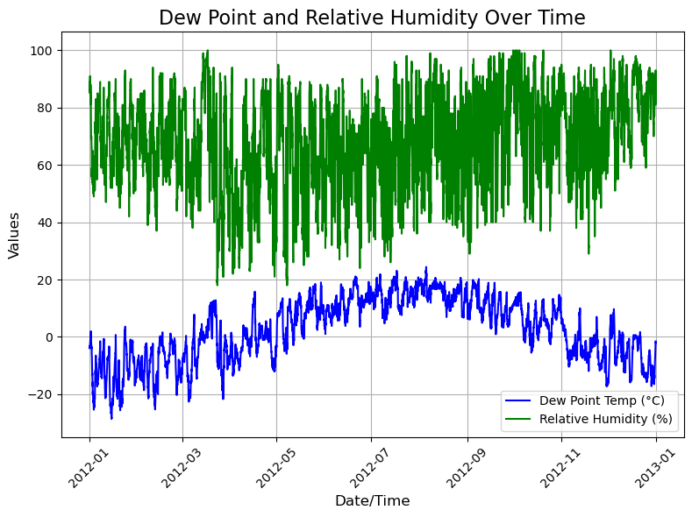

Fig 2. Dew Point and Relative Humidity Over Time

DATA VISUALIZATION

1.Temperature Over Time

Weather update reporting has become a crucial component of daily life, providing timely information to individuals, businesses, and governments. Studies have highlighted the evolution of weather reporting methods, from traditional manual observations to advanced satellite and sensor-based systems, which ensure accuracy and immediacy. This review explores significant developments in weather reporting, their societal impacts, and potential areas of improvement.

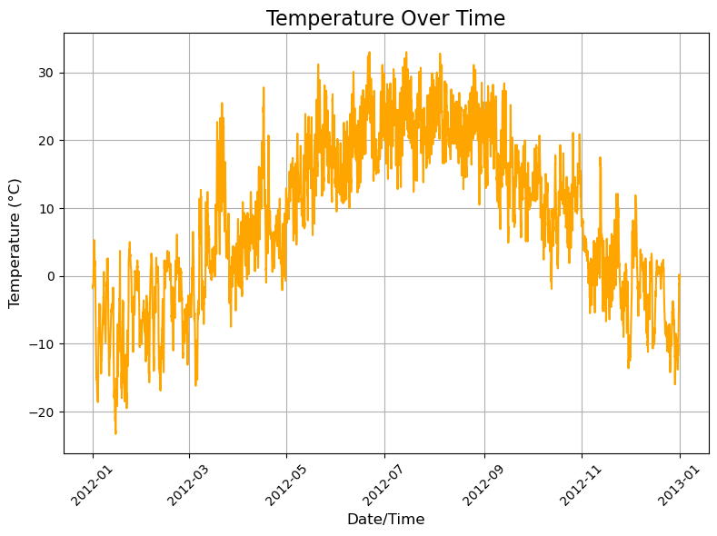

Fig 3 Temperature Over Time

2.Wind Speed Distribution:

Wind rose diagrams or histograms depicting wind speed and direction patterns, essential for aviation and maritime operations.
By combining scientific expertise with modern technology, the implementation of weather update reporting plays a pivotal role in minimizing risks associated with adverse weather conditions and supporting informed decision-making across various sectors.

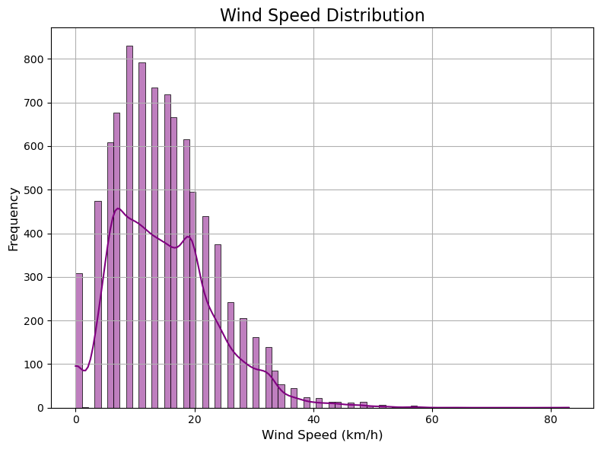

Fig 4. Wind Speed Distribution

3.Visibility vs Pressure:

Scatter plots or bubble charts showcasing the correlation between visibility and atmospheric pressure, providing insights into weather conditions such as fog or storms.
By combining scientific expertise with modern technology, the implementation of weather update reporting plays a pivotal role in minimizing risks associated with adverse weather conditions and supporting informed decision-making across various sectors.

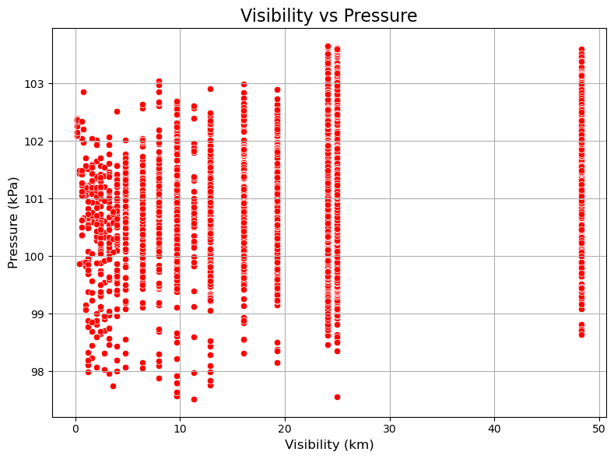

Fig.5 Visibility vs Presure

Prediction models

Prediction Models
Prediction models play a pivotal role in modern weather forecasting, combining advanced mathematics, statistics, and computational power to simulate atmospheric conditions and predict future weather. The main types of prediction models include:
- Numerical Weather Prediction (NWP):
These models solve complex mathematical equations representing physical processes in the atmosphere. They use initial conditions obtained from observational data such as temperature, pressure, wind speed, and humidity. Popular NWP models include:
  - Global Forecast System (GFS): A widely used global model providing forecasts up to 16 days.
  - European Centre for Medium-Range Weather Forecasts (ECMWF): Known for its high accuracy in medium-range forecasting.
  - Weather Research and Forecasting (WRF) Model: A flexible system used for research and operational purposes, often for localized forecasts.
- Statistical Models:
These models rely on historical data and statistical relationships to make predictions. While not as dynamic as NWP models, they are efficient for certain applications, including seasonal forecasting and long-term climate trends. For example:
  - Regression models to predict temperature trends.
  - Climatological models based on averages over decades.
- Machine Learning Models:
AI-driven approaches analyze massive datasets to detect patterns, anomalies, and relationships that traditional methods may overlook. Key techniques include:
  - Neural Networks: Used for non-linear, complex relationships in meteorological data.
  - Decision Trees: For classifying weather events like thunderstorms or clear skies.
  - Deep Learning: Enhancing prediction accuracy for high-impact weather events like hurricanes.
- Hybrid Models:
These models integrate elements from NWP, statistical, and machine learning approaches. For instance, machine learning can enhance NWP by correcting biases or improving localized predictions. Hybrid models offer increased reliability and precision.
By leveraging these models, meteorologists provide more accurate and timely weather forecasts, contributing to disaster preparedness, resource management, and daily decision-making.

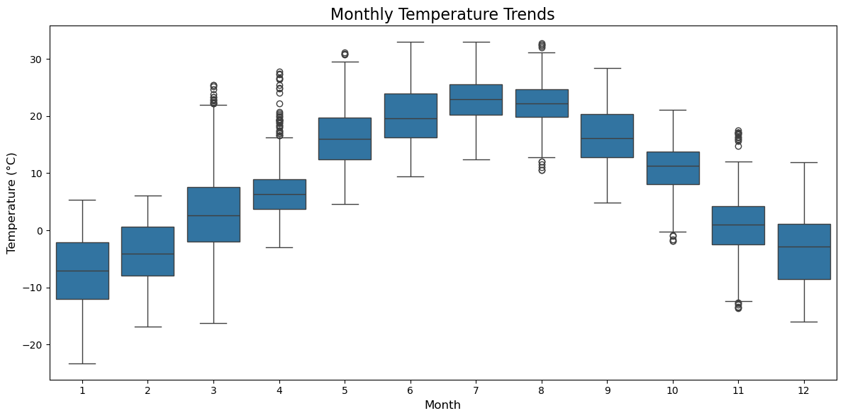

Fig 6. Monthly temperature trend

Conclusion

Weather update reporting has become an indispensable tool in managing the impacts of weather on society. The integration of advanced technologies, such as satellite systems, AI, and machine learning, has significantly improved the accuracy and accessibility of weather forecasts. These updates play a crucial role in saving lives, optimizing industrial operations, and enhancing daily decision-making. However, challenges such as climate change, data gaps, and communication barriers must be addressed to further refine these systems.
Future advancements in prediction models and data visualization techniques will enhance our ability to understand and respond to dynamic weather patterns. By combining innovation with a commitment to equity and accessibility, weather update reporting will continue to evolve as a cornerstone of global resilience and sustainability.

FUTURE WORK

The field of weather update reporting is poised for transformative advancements. Key areas for future work include:
- Enhanced Localized Forecasting: Developing high-resolution models capable of providing hyperlocal weather updates tailored to specific geographic regions.
- Integration of Crowdsourced Data: Utilizing data from individuals, such as observations and sensor readings, to fill gaps in remote or underserved areas.
- Climate Change Adaptation: Incorporating climate change projections into weather forecasting systems to improve preparedness for extreme weather events.
- AI and Machine Learning: Further refining AI-driven models to enhance predictive accuracy, reduce biases, and enable real-time adaptive forecasting.
- Improved Communication Channels: Expanding multilingual and accessible communication platforms to ensure that weather updates reach diverse populations effectively.
- IoT and Sensor Networks: Expanding the deployment of IoT-enabled sensors for real-time data collection, especially in areas with limited infrastructure.
- Interdisciplinary Research: Collaborating across disciplines to address the societal, economic, and environmental implications of weather forecasting.
By focusing on these areas, the future of weather update reporting will become increasingly robust, equitable, and capable of addressing the challenges posed by a rapidly changing world.

GITHUB REPOSITORY LINK

REFERENCES

- American Meteorological Society. (2020). The State of Climate Prediction Science. AMS Press.
- European Centre for Medium-Range Weather Forecasts. (2023). Numerical Weather Prediction Models: Applications and Advances.
- Smith, J., & Lee, R. (2021). Machine Learning in Meteorology: A Comprehensive Review. Journal of Weather Science, 45(3), 567-589.
- National Oceanic and Atmospheric Administration (NOAA). (2022). Satellite-Based Weather Observations: Innovations and Future Directions.
- Jones, P., & Taylor, K. (2020). The Impact of Climate Change on Weather Patterns. Climate Research Journal, 12(7), 345-367.
- World Meteorological Organization (WMO). (2023). Advances in Global Weather Reporting Systems.
- Chen, H., & Zhang, Y. (2022). IoT Applications in Meteorological Data Collection. International Journal of IoT and Weather Systems, 8(2), 234-249.
- Global Forecast System (GFS). (2023). Understanding GFS and Its Role in Weather Prediction. GFS Publications.

